**C#.net Challenge**

**Submit by Ayush Sharma**

* **Start project with Register.aspx.**

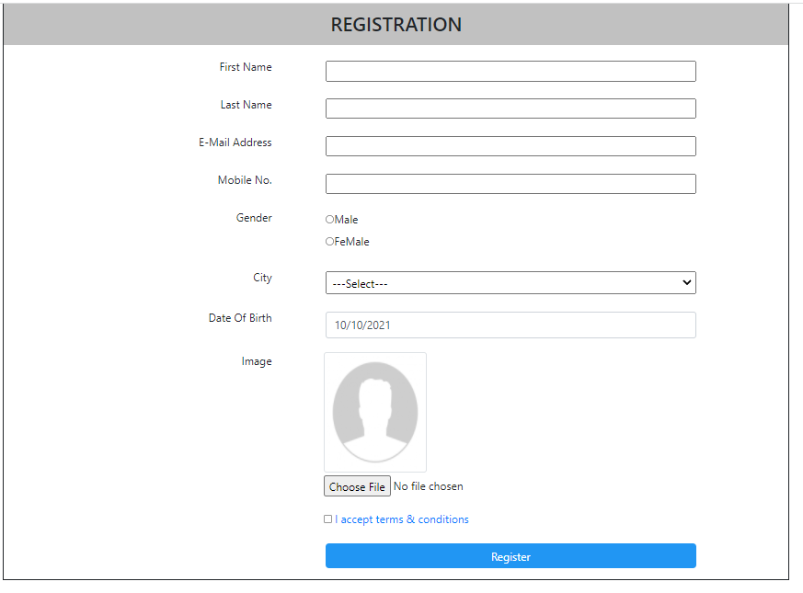

* **Register page contain Register information Field and user information gridview.**

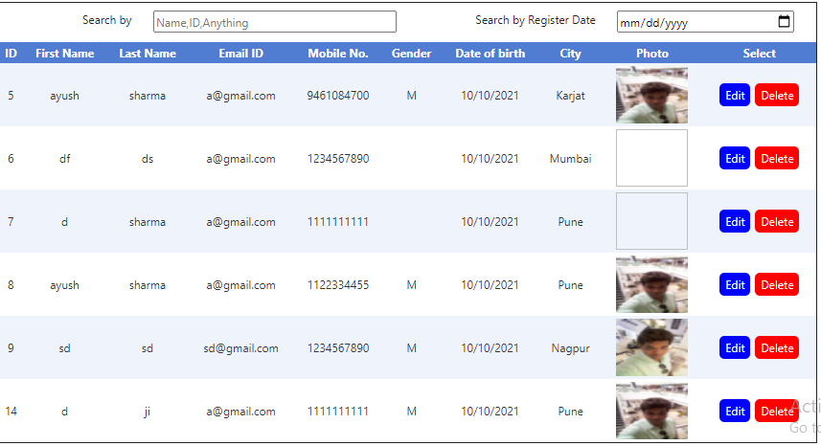

* **In gridview you can edit and delete user data.**
* **In Register page when you click on Register button it redirects to company information page.**





* **Company information page contain embedded youtube video,company logo**

**Company related images and description**

**And contacts.**